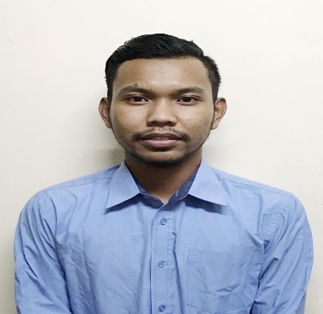

**MUHAMMAD IKHRAM BIN REZALI**

INTERNSHIP

NO 76 RUMAH BANJIR,

FELCRA SRI MAKMUR,

26030,KUANTAN,PAHANG

Phone no.: (h/p) 0174749781

Email: ikhram.im@gmail.com

**CAREER OBJECTIVE**

To apply my knowledge and skills in the field of Electrical engineering, to become more experience and able to build up my professional career.

**ACADEMIC QUALIFICATIONS**

|  |  |  |
| --- | --- | --- |
| NO. | YEAR | QUALIFICATIONS |
| 1 | 2013-  2017 | Bachelor in Engineering Technologies (Hons) in Electrical,  ( University Kuala Lumpur British Malaysian Institute )  CGPA: 2.6 |
| 2 | 2012-  2013 | Foundation in Science,  (Kolej Matrikulasi Pahang)  CGPA: 2.8 |
| 3 | 2007-  2011 | Sijil Pelajaran Malaysia(SPM),  (Sekolah Berasrama Penuh Integrasi Temerloh.)  SPM: 3A 5B 1C |

**CO-CURICULAR ACTIVITIES**

2007-2011

MSSM Pahang Football Tournament.

2013-2016

UniKL BMI Football League

UniKL BMI Futsal Tournament.

**AWARDS AND ACHIEVEMENT**

2010

Gold Medalist, MSSM Pahang Football Tournament.

2014-2015

Silver Medal, UniKL BMI Football League 2014

Gold medal, UniKL BMI Football League 2015

**SKILLS**

COMPUTER SKILLS

* Microsoft Office (MS Word, Excel, Powerpoint, Internet, etc)
* Capable to use Multisim software, Proteus, C++ programming, MATLAB, KEIL and Fuzzy Logic.

LANGUAGE SKILLS

* Malay language (10/10)
* English language (8/10)

TECHNICAL SKILLS

* Hardware constructing
* Hardware troubleshooting
* Able to use electrical tools and apparatus.

**SUBJECT LEARNED**

|  |  |
| --- | --- |
| * Engineering Mathematic * Circuit Theory * Power Electronics * Power System * Power Quality * Electrical System in Building | * Renewable Energy * Engineering Mechanics * Robotics * Control System * Electrical Machine and Drives * Measurement and Instrumention |

**MISCELLANEOUS**

* Expected salary:-
* Willing to travel: Yes
* Possess own transport: Yes
* Able to start as soon as possible by the end of the Semester 7.
* Expected date 12 Feb 2017.

**REFERENCES**

|  |  |
| --- | --- |
| **Ahmad Zaki Bin Abd Karim**  **Final Year Project Advisor,** Universiti Kuala Lumpur  British Malaysian Institute,  Batu 8, Jalan Sungai Pusu  53100 Gombak  Selangor Darul Ehsan  **Phone no.: 010-2519729**  **Email : ahmadzaki@bmi.unikl.edu.my** | **Zakaria Bin Ismail**  **Academic Advisor,** Universiti Kuala Lumpur  British Malaysian Institute,  Batu 8, Jalan Sungai Pusu  53100 Gombak  Selangor Darul Ehsan  **Email : zakaria@bmi.unikl.edu.my** |